MATLAB CODE SIGNALS AND

SYSTEMS-3

Supreet

Febuary 8, 2019

**Objective: -**

1. Generation of different signals and exploration of different functions related to signals processing in MATLAB
2. Perform basic operations on the signals

**Requirements: -**

1. MATLAB software

**Theory: -**

A **signal** is a function that "conveys information about the behaviour or attributes of some phenomenon". A **signal** may also be defined as an "observable change in a quantifiable entity".

Additive white Gaussian noise is a basic noise model used in Information theory to mimic the effect of many random processes that occur in nature. The modifiers denote specific characteristics: Additive because it is added to any noise that might be intrinsic to the information system.

**Convolution** is a mathematical operation on **two** functions, or in our case on **two vectors**. In this tutorial **the** simplest 1D **convolution** is to be explained, but of course this operation works for higher dimensions as well. It can be used for several tasks, for example signal or image processing.

**CODE:-**

**Q.1**

n = 0: 1:200-1;  
fun_s = @(n) 20*(0.9).^n;  
s = fun_s(n);  
S = RandStream('mt19937ar','Seed',5489);  
x = awgn(s,5,'measured');  
plot(n,[x]);  
hold on  
plot(n, s,'m');  
M = 5;  
y = sum2(x,M);  
hold on  
plot(n, y, 'r');  
  
M = 10;  
y = sum2(x,M);  
hold on  
plot(n, y, 'c');  
  
M = 20;  
y = sum2(x,M);  
hold on  
plot(n, y, 'k');  
  
  
legend('s[n]','original signal x[n]','y[n] M=5','y[n] M=10','y[n] M=20');

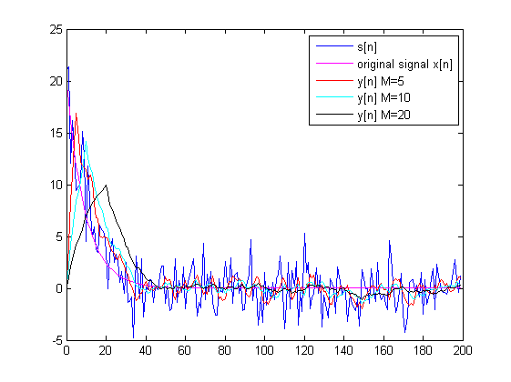

[*Published with MATLAB® R2014a*](http://www.mathworks.com/products/matlab)

**OBSERVATIONS:-**

With increase of weights the signals measuring window decreases, hence message is smoothened but on cost of the precision wave. So, conclusion is the weigth must be with respect to the frequeny of change of the signal.

Q.2

x = [-2 0 1 -1 3];  
y = [1 2 0 -1];  
w = conv(x,y);  
  
subplot(2,2,1);  
plot((0:length(x)-1),x);  
xlabel('Time (sec)');  
ylabel('Amplitude') ;  
title('a');  
  
subplot(2,2,2);  
plot((0:length(y)-1),y);  
xlabel('Time (sec)');  
ylabel('Amplitude') ;  
title('b');  
  
subplot(2,2,3);  
plot((0:length(w)-1),w);  
xlabel('Time (sec)');  
ylabel('Amplitude') ;  
title('covulation(a,b)');

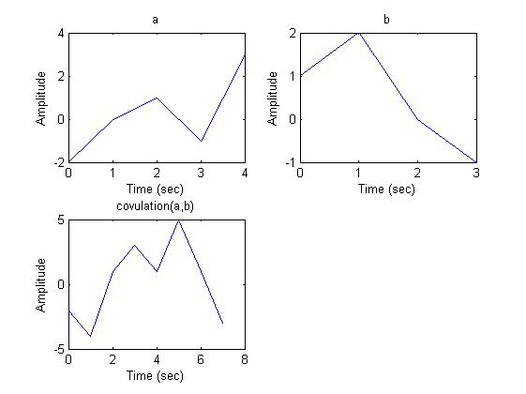

[*Published with MATLAB® R2014a*](http://www.mathworks.com/products/matlab)

Q.3

clear all;  
clc;  
n = 1:1:10;  
l = [1 1 -0.6];  
m = [0.8 -0.44 -0.36 0.02];  
a = ones(1,10);  
b = filter(m,l,a);  
stem(n,b);

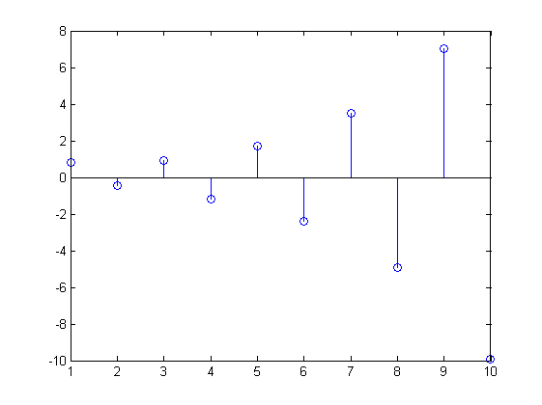

[*Published with MATLAB® R2014a*](http://www.mathworks.com/products/matlab)

Q.4

x = [1 3 -2 1 2 -1 4 4 2];  
y = [2 -1 4 1 -2 3];  
w = xcorr(x,y);  
  
subplot(2,2,1);  
plot((0:length(x)-1),x);  
xlabel('Time (sec)');  
ylabel('Amplitude') ;  
title('x');  
  
subplot(2,2,2);  
plot((0:length(y)-1),y);  
xlabel('Time (sec)');  
ylabel('Amplitude') ;  
title('y');  
  
subplot(2,2,3);  
plot((0:length(w)-1),w);  
xlabel('Time (sec)');  
ylabel('Amplitude') ;  
title('co-relation(x,y)');

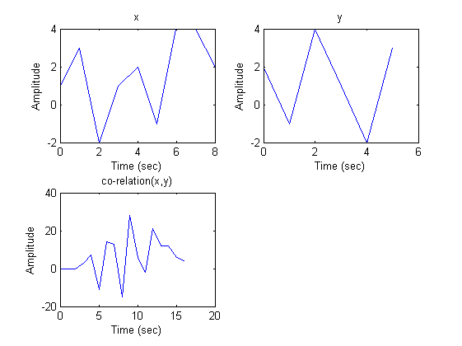

[*Published with MATLAB® R2014a*](http://www.mathworks.com/products/matlab)

Q.5

h = [1 1 1];  
x = [0.5 2];  
w = conv(h,x);  
  
subplot(2,2,1);  
plot((0:length(w)-1),w);  
  
subplot(2,2,2);  
plot((0:length(x)-1),x);  
  
subplot(2,2,3);  
plot((0:length(h)-1),h);

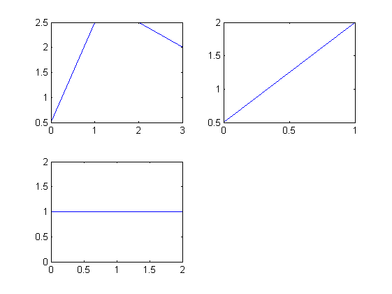

[*Published with MATLAB® R2014a*](http://www.mathworks.com/products/matlab)

Q.6

n = 0:1:200-1;  
a = 0.9;  
fun_x = @(n) (a.^n).*step1(n);  
x = fun_x(n);  
h = step1(n);  
w = conv(x,h);  
o = 0:length(w)-1;  
subplot(2,2,1);  
plot((0:length(x)-1),x);  
subplot(2,2,2);  
plot((0:length(h)-1),h);  
subplot(2,2,3);  
plot(o,w);  
hold on;  
  
a = 1;  
fun_x = @(n) (a.^n).*step1(n);  
x = fun_x(n);  
w = conv(x,h);  
plot(o,w,'r');  
hold on;  
  
a = 10;  
fun_x = @(n) (a.^n).*step1(n);  
x = fun_x(n);  
w = conv(x,h);  
plot(o,w,'y');

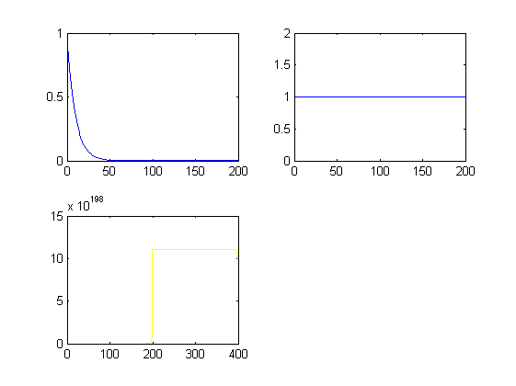

[*Published with MATLAB® R2014a*](http://www.mathworks.com/products/matlab)

**OBSERVATION:-**

**All the graphs have been displayed and parameters are verified.**

**CONCLUSION:-**

**All operations in different signals were executed.**